DRAFT DMMP Clarification Paper March 24, 2025

## Overdepth Characterization

Prepared by the Dredged Material Management Program agencies

### Introduction

As presented in both the 2023 and 2024 SMARMs, non-compliance of the United States Army Corps of Engineers (USACE) issued dredging permit[1] and associated Washington State Department of Ecology Section 401 Water Quality Certification[2] have been on the rise in recent years. In most instances of non-compliance of the USACE permit there is also non-compliance of the Washington State Department of Natural Resources issued site use authorization. Non-compliance issues span a wide range of actions, including unauthorized dredging, overdredging, debris management, transloading, and not following best management practices in approved project plans. The most common non-compliance issue is dredging beyond permitted depth (i.e., overdredging).

Overdredging may result in exceeding a project’s permitted dredge and disposal volumes and can expose post-dredge surfaces that could have known or potential sediment contamination. In order to assess a project for compliance of the Washington State antidegradation policy[3], characterization depths must be representative of post-construction dredge depths.

A contributing cause for non-compliance identified by the DMMP was designing the sediment characterization and permit with a 1-foot (ft) overdepth (OD) allowance. In most projects, this extra +1 ft beyond the maintenance depth is “payable” meaning the dredger has incentive to remove it. For a dredger to remove this extra foot but nothing deeper implies a high level of dredging precision, which is not typically achievable for several reasons including:

* Equipment and production limitations. Maintenance dredging tends to be as efficient as possible to minimize project costs. These efficiencies reduce the accuracy of the dredge depth. Higher accuracy (< 1 ft) can be achieved but requires an experienced dredger, on-site tide gauge, specialized equipment (level cut buckets), and slow dredging cycles, which all increase costs. If these increased measures are not being taken, precision dredging should not be assumed.
* When there is large debris present (often near rock armored slopes or when derelict piles are present), there is often a “hole” left behind when the object is removed, which can extend below characterized depths.

Nomenclature may also contribute to dredging beyond characterized or permitted depths due to different understandings of terms between regulators, project proponents, and dredgers. The following are common regulatory terms used for defining dredge depths.

* Maintenance depth - the depth required for operation of the facility.
* Overdepth - determined by project proponent. A +1 ft or +2 ft OD allowance is usually included in the permit and associated sediment characterization.
* Permitted depth - determined by project proponent, it’s the maximum depth allowed under various permits and certifications. For a project with +2 ft of OD, this can look like, “-47 ft MLLW, which includes -45 ft maintenance + 2 ft OD.
* Characterized depth - deepest depth an area has been characterized, may differ across project area.
* Payable depth - contractual term between project proponent and dredger; maximum depth that contractor is paid to remove. Often, project proponents pay one foot beyond the desired depth to assure there are no high spots but will not pay for anything deeper.
* Advanced maintenance - added depth that will purposefully be dredged, to reduce the frequency of dredging events. If advanced maintenance is proposed, it must be included in the permit and characterization.
* Z-layer/Leave Surface - the post-dredge surface. A representative sample of the Z-layer (Z-sample) is collected and archived during sediment sampling.

The Dredged Material Management Program (DMMP) User Manual (DMMP 2021) requires characterization of the entire dredge prism (maintenance depth plus OD) and collection of a Z-layer sample (2 ft below the dredge prism) is recommended. The User Manual does not specify how much overdepth to include and assumes that the permitted depth and characterization depth would be the same.

### Clarification

In response to increasing non-compliance issues associated with overdredging, the DMMP agencies recommend that applicants characterize +2ft OD even if the permits only include +1 ft OD. Permit compliance is based on permitted depth, but characterization depth aids the DMMP agencies in understanding non-compliance impacts to disposal and water quality.

If the applicant chooses to characterize +1 ft OD, the underlaying Z-layer samples [4] will be analyzed up front so overdredging risks can be evaluated prior to dredging (Figure 1).

Up front Z-layer analysis could be waived for special cases based on:

* Availability of historical Z-layer data to verify that there is no contamination
* Known native interface
* Rank

Figure 1: Overdepth Characterization and Z-layer Sample Analysis

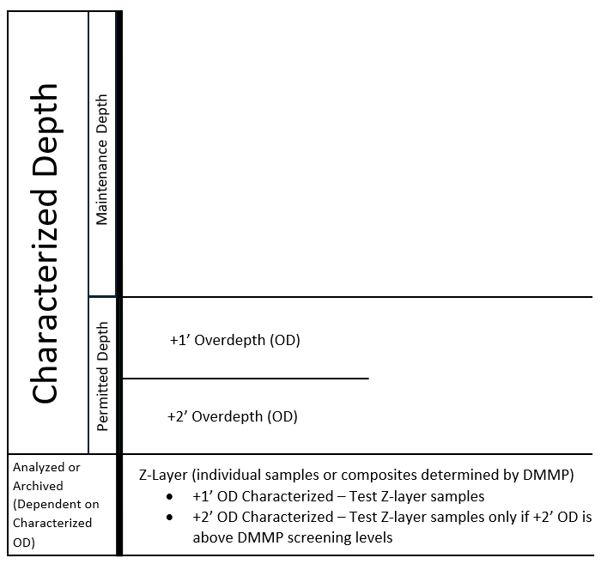

### References

DMMP 2021. *Dredged Material Evaluation and Disposal Procedures (User Manual)*. Dredged Material Management Program, updated July 2021.

1. Clean Water Act (CWA) Section 404
2. CWA Section 401
3. WAC 173-200-030 and 40 C.F.R. § 131.12
4. The DMMP agencies will determine if individual Z-samples or Z-sample composites are warranted based on available information.